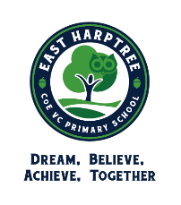

Warn and Inform Letter

22nd November 2021
Dear Parents and Carers,
We have been advised that there are three additional confirmed cases of COVID-19 in the school community (Squirrels Class) in addition to the two confirmed cases (Fox class) last week.
We know that you may find this concerning but are continuing to monitor the situation. Your child should continue to attend school if they remain well. Please be reassured that for most people, coronavirus (COVID-19) will be a mild illness. We are asking that you remain particularly vigilant with regards to looking out for symptoms and that you continue using the asymptomatic Lateral Flow Devices for COVID-19 testing.
Symptoms of coronavirus (COVID-19) are a new, continuous cough, or a high temperature, or a loss of, or change in, their normal sense of taste or smell (anosmia). If your child develops symptoms of coronavirus (COVID-19), they should get a PCR test and remain at home at least until the result is known and they are fever free (without medication) for at least 24 hours. If negative, the child can end self-isolation; If positive, the child should isolate until at least 10 days after their symptoms appeared. If your child has a positive test result, but does not have symptoms, they should stay at home and self-isolate for 10 days from the date the positive test was taken. This isolation period will be extended if they go on to develop symptoms by counting 10 full days from the day following their symptom onset.
We kindly request that anyone in a household where there is a positive case continues to regularly test other family members that are coming into school.
Anyone with symptoms will be eligible for a PCR test (the normally available test type) and this can be arranged via https://www.gov.uk/get-coronavirus-test or by calling 119.
Thank you for your continued support.

Yours faithfully
Ian Harvey
Headteacher

